**SDF LAB 2 PROJECT**

**BANK MANAGEMENT SYSTEM**



**MEMBERS:**1.Ganesh G Setty - 20103223

2. Yash Mangla - 20103231

3. Khushi Rana - 20103222

4. Anish Jain - 20103226

**Submitted to** - ANITA SAHOO

**INTRODUCTION**

The Bank Management System uses classes and file handling features of C++ in order to store all the user’s data. An external file is created by the system, so every time we get into the system we can operate with the existing account. The system allows tasks like creating an account, deposit/withdraw an amount, check balance, view all account holder’s details, close an account and modify an account.

**OBJECTIVE**

The main objectives of the Bank Management System are to let a user

1. create an account by providing the name of the account holder, account number, select amount type whether its Saving account or Current account and providing an initial amount.
2. deposit and withdraw money just by providing his/her account number (the system displays his/her profile) and entering an amount.
3. check his/her balance (display the account holder’s name with account number type and amount).
4. check for all the account holder’s list.
5. close their account by providing their account number
6. modify their account details and type if they want to.

**CODE**

#include<iostream>

#include<fstream>

#include<cctype>

#include<iomanip>

using namespace std;

class account

{

int acno;

char name[50];

int deposit;

char type;

public:

void create_account(); //function to get data from user

void show_account() const; //function to show data on screen

void modify(); //function to add new data

void dep(int); //function to accept amount and add to balance amount

void draw(int); //function to accept amount and subtract from balance

amount

void report() const; //function to show data in tabular format

int retacno() const; //function to return account number

int retdeposit() const; //function to return balance amount

char rettype() const; //function to return type of account

};

void account::create_account()

{

cout<<"Enter The account No. :";

cin>>acno;

cout<<"Enter The Name of The account Holder : ";

cin.ignore();

cin.getline(name,50);

cout<<"Enter Type of The account (C/S) : ";

cin>>type;

type=toupper(type);

cout<<"Enter The Initial amount(>=500 for Saving and >=1000 for current ) : ";

cin>>deposit;

cout<<"\n\n\nAccount Created..";

}

void account::show_account() const

{

cout<<"\nAccount No. : "<<acno;

cout<<"\nAccount Holder Name : ";

cout<<name;

cout<<"\nType of Account : "<<type;

cout<<"\nBalance amount : "<<deposit;

}

void account::modify()

{

cout<<"\nAccount No. : "<<acno;

cout<<"\nModify Account Holder Name : ";

cin.ignore();

cin.getline(name,50);

cout<<"\nModify Type of Account : ";

cin>>type;

type=toupper(type);

cout<<"\nModify Balance amount : ";

cin>>deposit;

}

void account::dep(int x)

{

deposit+=x;

}

void account::draw(int x)

{

deposit-=x;

}

void account::report() const

{

cout<<acno<<setw(10)<<" "<<name<<setw(10)<<" "<<type<<setw(6)<<deposit<<endl;

}

int account::retacno() const

{

return acno;

}

int account::retdeposit() const

{

return deposit;

}

char account::rettype() const

{

return type;

}

void write_account(); //function to write record in binary file

void display_sp(int); //function to display account details given by user

void modify_account(int); //function to modify record of file

void delete_account(int); //function to delete record of file

void display_all(); //function to display all account details

void deposit_withdraw(int, int); // function to desposit/withdraw amount for given account

void intro(); //introductory screen function

int main()

{

char ch;

int num;

do

{

system("cls");

cout<<"\n MAIN MENU";

cout<<"\n01. NEW ACCOUNT";

cout<<"\n02. DEPOSIT AMOUNT";

cout<<"\n03. WITHDRAW AMOUNT";

cout<<"\n04. BALANCE ENQUIRY";

cout<<"\n05. ALL ACCOUNT HOLDER LIST";

cout<<"\n06. CLOSE AN ACCOUNT";

cout<<"\n07. MODIFY AN ACCOUNT";

cout<<"\n08. EXIT";

cout<<"\n\nSelect Your Option (1-8) ";

cin>>ch;

system("cls");

switch(ch)

{

case '1':

write_account();

break;

case '2':

cout<<"Enter The account No. : "; cin>>num;

deposit_withdraw(num, 1);

break;

case '3':

cout<<"Enter The account No. : "; cin>>num;

deposit_withdraw(num, 2);

break;

case '4':

cout<<"Enter The account No. : "; cin>>num;

display_sp(num);

break;

case '5':

display_all();

break;

case '6':

cout<<"Enter The account No. : "; cin>>num;

delete_account(num);

break;

case '7':

cout<<"Enter The account No. : "; cin>>num;

modify_account(num);

break;

case '8':

cout<<"Thanks for using bank managemnt system";

break;

default :cout<<"\a";

}

cin.ignore();

cin.get();

}while(ch!='8');

return 0;

}

void write_account()

{

account ac;

ofstream outFile;

outFile.open("account.dat",ios::binary|ios::app);

ac.create_account();

outFile.write(reinterpret_cast<char *> (&ac), sizeof(account));

outFile.close();

}

void display_sp(int n)

{

account ac;

bool flag=false;

ifstream inFile;

inFile.open("account.dat",ios::binary);

if(!inFile)

{

cout<<"File could not be open !! Press any Key...";

return;

}

cout<<"\nBALANCE DETAILS\n";

while(inFile.read(reinterpret_cast<char *> (&ac), sizeof(account)))

{

if(ac.retacno()==n)

{

ac.show_account();

flag=true;

}

}

inFile.close();

if(flag==false)

cout<<"\n\nAccount number does not exist";

}

void modify_account(int n)

{

bool found=false;

account ac;

fstream File;

File.open("account.dat",ios::binary|ios::in|ios::out);

if(!File)

{

cout<<"File could not be open !! Press any Key...";

return;

}

while(!File.eof() && found==false)

{

File.read(reinterpret_cast<char *> (&ac), sizeof(account));

if(ac.retacno()==n)

{

ac.show_account();

cout<<"\n\nEnter The New Details of account"<<endl;

ac.modify();

int pos=(-1)*static_cast<int>(sizeof(account));

File.seekp(pos,ios::cur);

File.write(reinterpret_cast<char *> (&ac), sizeof(account));

cout<<"\n\n\t Record Updated";

found=true;

}

}

File.close();

if(found==false)

cout<<"\n\n Record Not Found ";

}

void delete_account(int n)

{

account ac;

ifstream inFile;

ofstream outFile;

inFile.open("account.dat",ios::binary);

if(!inFile)

{

cout<<"File could not be open !! Press any Key...";

return;

}

outFile.open("Temp.dat",ios::binary);

inFile.seekg(0,ios::beg);

while(inFile.read(reinterpret_cast<char *> (&ac), sizeof(account)))

{

if(ac.retacno()!=n)

{

outFile.write(reinterpret_cast<char *> (&ac), sizeof(account));

}

}

inFile.close();

outFile.close();

remove("account.dat");

rename("Temp.dat","account.dat");

cout<<"\n\n\tRecord Deleted ..";

}

void display_all()

{

account ac;

ifstream inFile;

inFile.open("account.dat",ios::binary);

if(!inFile)

{

cout<<"File could not be open !! Press any Key...";

return;

}

cout<<"\n\n\t\tACCOUNT HOLDER LIST\n\n";

cout<<"====================================================\n";

cout<<"A/c no. NAME Type Balance\n";

cout<<"====================================================\n";

while(inFile.read(reinterpret_cast<char *> (&ac), sizeof(account)))

{

ac.report();

}

inFile.close();

}

void deposit_withdraw(int n, int option)

{

int amt;

bool found=false;

account ac;

fstream File;

File.open("account.dat", ios::binary|ios::in|ios::out);

if(!File)

{

cout<<"File could not be open !! Press any Key...";

return;

}

while(!File.eof() && found==false)

{

File.read(reinterpret_cast<char *> (&ac), sizeof(account));

if(ac.retacno()==n)

{

ac.show_account();

if(option==1)

{

cout<<"\n\n\tTO DEPOSIT AMOUNT ";

cout<<"\n\nEnter The amount to be deposited: ";

cin>>amt;

ac.dep(amt);

}

if(option==2)

{

cout<<"\n\n\tTO WITHDRAW AMOUNT ";

cout<<"\n\nEnter The amount to be withdrawn: ";

cin>>amt;

int bal=ac.retdeposit()-amt;

if((bal<500 && ac.rettype()=='S') || (bal<1000 && ac.rettype()=='C'))

cout<<"Insufficience balance";

else

ac.draw(amt);

}

int pos=(-1)*static_cast<int>(sizeof(ac));

File.seekp(pos,ios::cur);

File.write(reinterpret_cast<char *> (&ac), sizeof(account));

cout<<"\n\n\t Record Updated";

found=true;

}

}

File.close();

if(found==false)

cout<<"\n\n Record Not Found ";

}

**RESULT/DISCUSSION**

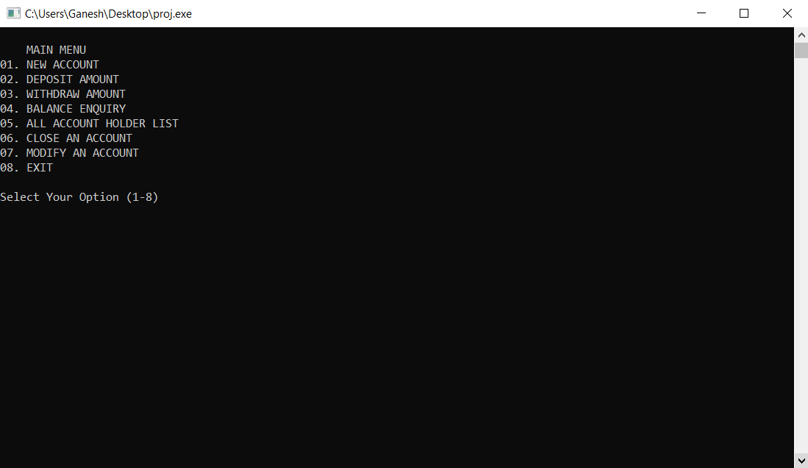

**OPTION 1**

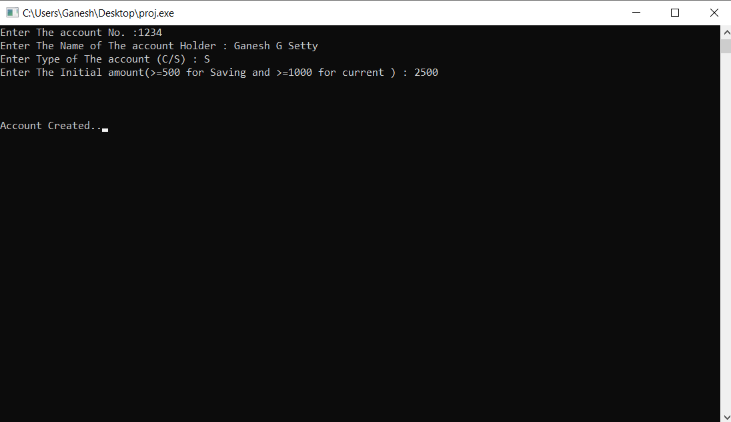

**OPTION 2**

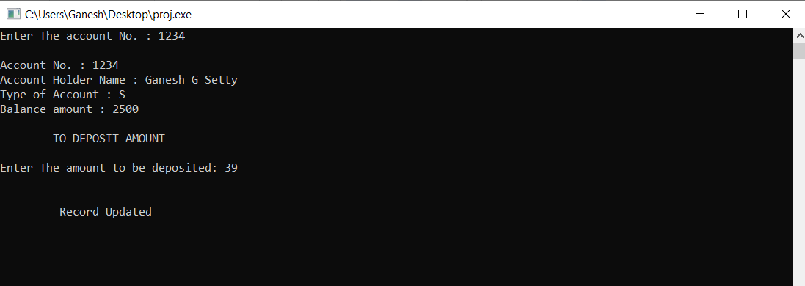

**OPTION 3**

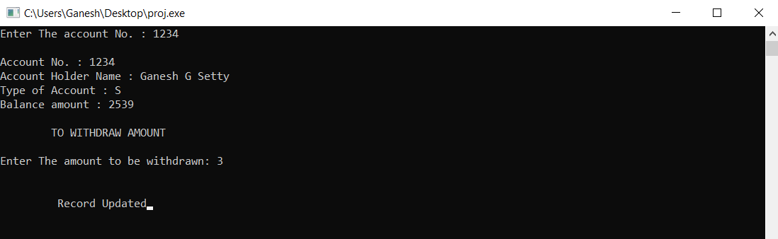

**OPTION 4**

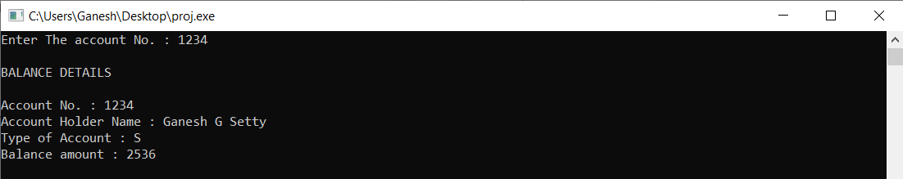

**OPTION 5**

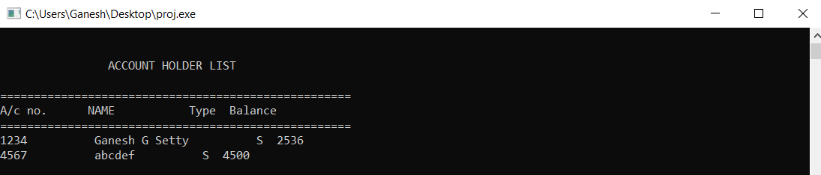

**OPTION 6**

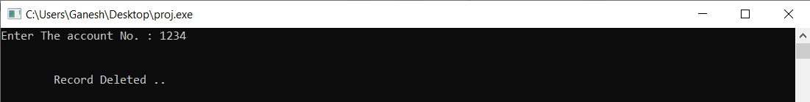

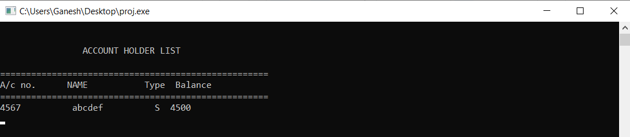

**OPTION 7**

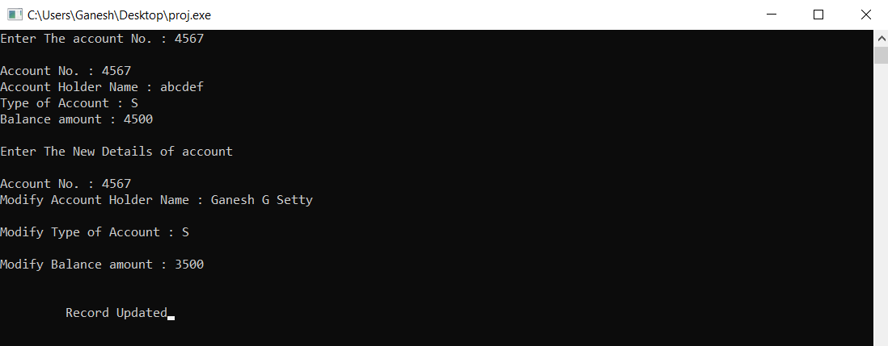

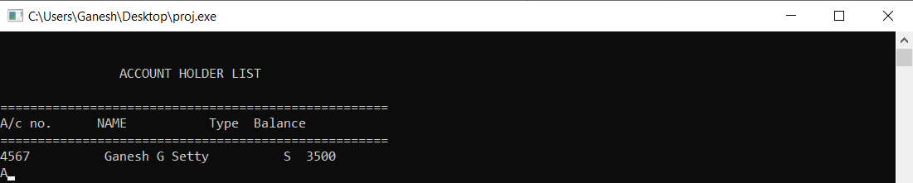

**OPTION 8**



**REFERENCES**

https://www.cplusplus.com/